深圳大学考试答题纸
二○二三～二○二四学年度第 二 学期 2024年5月10日
课程编号 | 2801000049 | 课序号 |  |  |  | 课程名称 |  | 机器学习 |  | 主讲教师 | 麦晓春 | 评分
学 号 | 2022300013 |  | 姓名 |  | 卫宏林 |  | 专业年级 |  | 文华班
Question:
Suppose you have an array containing information about n individuals. Each person is represented separately by a string (their name) and a number (their position on the number axis). Each person has 5 friends, i.e., the 5 people whose numbers are closest to his own. Write an algorithm that can find each person's 5 friends.
Method:
- Assume an array containing information about n individuals
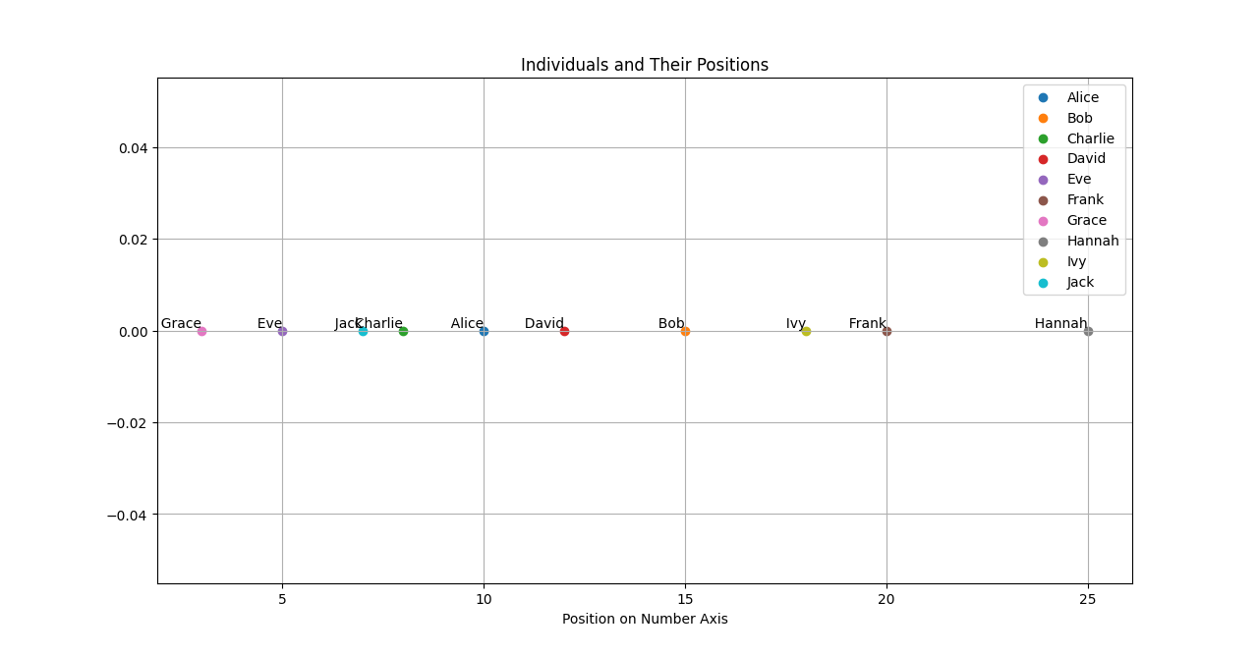
- Calculate the distance between two individuals based on their positions
- Sort distances and select the 5 closest friends
- Output the result
Alice's friends: ['Charlie', 'David', 'Jack', 'Bob', 'Eve']
Bob's friends: ['David', 'Ivy', 'Alice', 'Frank', 'Charlie']
Charlie's friends: ['Jack', 'Alice', 'Eve', 'David', 'Grace']
David's friends: ['Alice', 'Bob', 'Charlie', 'Jack', 'Ivy']
Eve's friends: ['Grace', 'Jack', 'Charlie', 'Alice', 'David']
Frank's friends: ['Ivy', 'Bob', 'Hannah', 'David', 'Alice']
Grace's friends: ['Eve', 'Jack', 'Charlie', 'Alice', 'David']
Hannah's friends: ['Frank', 'Ivy', 'Bob', 'David', 'Alice']
Ivy's friends: ['Frank', 'Bob', 'David', 'Hannah', 'Alice']
Jack's friends: ['Charlie', 'Eve', 'Alice', 'Grace', 'David']

Code appendix
import matplotlib.pyplot as plt
def calculate_distance(person1, person2):
# Calculate the distance between two individuals based on their positions
distance = abs(person1[1] - person2[1])
return distance

def find_friends(individuals):
friends_dict = {}

for person1 in individuals:
distances = []
for person2 in individuals:
if person1 != person2:
distance = calculate_distance(person1, person2)
distances.append((person2[0], distance)) # Store name and distance

# Sort distances and select the 5 closest friends
distances.sort(key=lambda x: x[1])
friends = [distances[i][0] for i in range(min(5, len(distances)))]
friends_dict[person1[0]] = friends

return friends_dict

# Example input data
individuals = [("Alice", 10), ("Bob", 15), ("Charlie", 8), ("David", 12), ("Eve", 5), ("Frank", 20), ("Grace", 3), ("Hannah", 25), ("Ivy", 18), ("Jack", 7)]

# Find friends for each individual
friends = find_friends(individuals)

# Plotting
plt.figure(figsize=(10, 6))
for person, position in individuals:
plt.scatter(position, 0, label=person, marker='o')
plt.text(position, 0, f' {person}', verticalalignment='bottom', horizontalalignment='right')

plt.xlabel('Position on Number Axis')
plt.title('Individuals and Their Positions')
plt.grid(True)
plt.legend()
plt.show()
# Output the result
for person, friend_list in friends.items():
print(f"{person}'s friends: {friend_list}")

